
PinJig Remarking Rules –
Structural Manufacturing

PinJig Remarking Rules.doc
Status: Draft
Author: StructMfg-Team

SM3D Concept Design Document.
December 12 , 2011
© 2011 Intergraph Corporation. All rights reserved.
The content of this document is proprietary work of Intergraph Corporation, or relevant third parties, and is protected by copyright law and international treaty. Any use, duplication, distribution or disclosure of such, other than as specified herein, is unauthorized and in violation of applicable copyright law and international treaty. All rights in content or materials bearing copyright notice or other attribution of third party rights are reserved to the relevant third party. United States Government license rights are limited to those mandatory rights identified in DFARS 252.227-7015(b).
Intergraph may make improvements and/or changes in the products and/or the programs described in this publication at any time without notice.
Any content or materials supplied hereunder are provided "as is," without warranty of any kind, either expressed or implied, including, but not limited to, any implied warranties of merchantability, fitness for a particular purpose, or against infringement. In no event shall Intergraph be liable for any damages arising out of, or in connection with the downloading, viewing, use, duplication, distribution or disclosure of any content or material published by Intergraph, including but not limited to any direct, indirect, incidental, special, punitive or consequential damages, or loss or corruption of data.
Some jurisdictions do not allow the exclusions or limitations set forth above, so the above may not apply to you. The exclusions or limitations shall apply in all jurisdictions to the maximum extent allowed by law.

Intergraph Corporation
170 Graphics Drive
Madison, AL 35758
Phone: +1.256.730.2000
Toll Free USA: +1.800.345.4856
Fax: +256.730.2048

Contents
Introduction 2
References 2
Definitions 2
Bulkload 3
Rule Framework and Implementation 4

Revision # | Date Revised | Revised By | Description
0.1 | 12- Dec- 2011 | Manasa Jaisetty | Initial Version.

Introduction
The purpose of this document is to describe the framework of PinJig remarking rules. The document would explain the following remarking rule sets in detail:
- Default
- Based On Logical Connection
- Based On Physical Connection
- Based On Part Surface and Logical Connection

References

CR-CP-200725 | Ability to show the molded and antimolded sides of the deck using LC

Definitions

Bulkload
- The remarking rule sets are available in “MfgPinJigRemarkingRuleSet” sheet in “AllStructMfgCodeLists.xls” workbook. Users can add new add new rule sets to this sheet and bulkload in AMD mode .
Location: “\ShipCatalogData\BulkLoad\DataFiles\StructManufacturing\AllStructMfgCodeLists.xls”
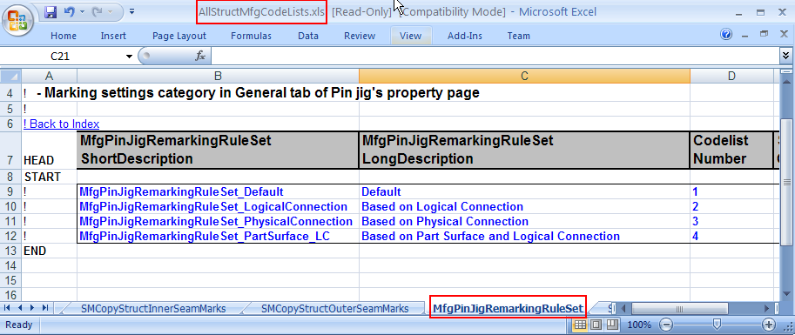
- The SRD rule related to remarking is present in the “MfgPinJigRules” sheet(RuleType = 413) . User can modify the ProgID of the existing rule or add new rule by bulkloading in AMD mode (Need to put “A” in place of “!’ in front of the rule name).
Location: “\ShipCatalogData\BulkLoad\DataFiles\StructManufacturing\StructMfgSettings.xls”
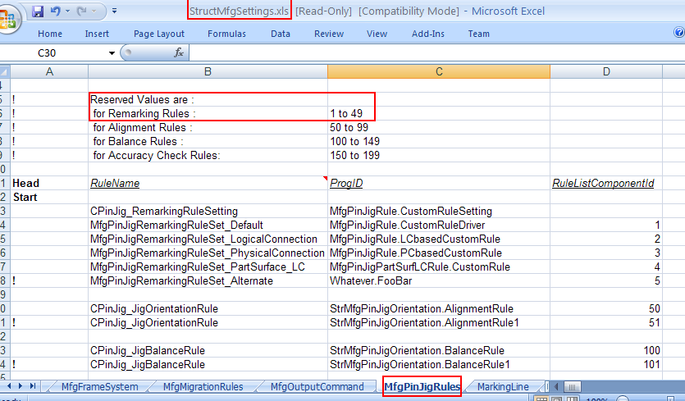

Rule Framework and Implementation

The remarking rules are delivered at the below locations:
- “\SharedContent\Src\StructManufacturing\Rules\PinJig\Remarking” which provides implementation for the following rule sets:
- Default
- Based on Logical connection
- Based On Physical Connection
- “\SharedContent\Src\StructManufacturing\Rules\PinJig\PartSurfaceRemarking” which provides implementation for the following rule set:
  - Based On Part Surface and Logical Connection

“CustomRuleSetting.cls” is the class file which proposes the remarking rule set that needs to be picked up based on the selected supported plates.

The purpose of remarking rule set is to return the following:
- Surface to be used for remarking
- Collection of entities to remark
- PinJig remarking geometry collection
- Set of remarking types towards an input purpose such as types to be excluded from intersection point creation etc.

Each rule set is associated with a driver class. Based on the remarking type, this rule driver class forwards the calls to the corresponding remarking rule type. Following are the various remarking rule types:
- Seam remarking
- Plate remarking
- Profile remarking
- Frame Line remarking
- Longitudinal remarking
- Buttock remarking
- Reference curve remarking - includes knuckles, naval arch marks,tangent lines
- User remarking lines - User defined marking lines
- User extensions - User defined marking lines placed for extension purpose
DEFAULT RULE SET: This rule set is identical to “Based On Physical connection”. Users can provide their default implementation in this rule.

“CustomRuleDriver.cls” is the driver class which has the default remarking rule implementation.
- “SeamRemark_ButtPC.cls” holds the implementation for seam remarking rule.
- “PhyConnPlateRemarking.cls” holds the implementation for plate remarking rule.
- “PhyConnProfileRemarking.cls” holds the implementation for profile remarking rule.
- “FrameLines.cls” holds the implementation for frame remarking rule.
- “LongitudinalLines.cls” holds the implementation for longitudinal remarking rule.
- “ButtockLines.cls” holds the implementation for buttock remarking rule.
- “NavalArchLines.cls” holds the implementation for reference curve remarking rule.
- “CreateLinesFromUserMarks.cls” holds the implementation for user remarking rule.
- “ExtendLinesFromUserMarks.cls” holds the implementation for user extension remarking rule.

BASED ON PHYSICAL CONNECTION RULE SET:
Generates the remarking surface by stitching the surfaces of the sides of the supported plate parts that face away from the jig floor. This option uses the physical connections between the following objects:
- Supported plates and connected plates for plate remarking lines.
- Supported plates and connected profiles for profile remarking lines.
- Supported plates for seam remarking lines.
The geometry for these remarking lines corresponds to the portion of the physical connection geometry that lies on the remarking surface.

“PCbasedCustomRule.cls” is the driver class which has the physical connection based remarking rule implementation.
The class files invoked for the individual remarking types are same as that of the default rule set.

BASED ON LOGICAL CONNECTION RULE SET:
Generates the remarking surface by stitching together the surfaces of the leaf plate systems of the supported plates. It uses the existing geometry (as-is) of logical connections between the following objects:
- Supported plates and connected plates for plate remarking lines.
- Supported plates and connected profiles for profile remarking lines.
- Supported plates for seam remarking lines.
“LCbasedCustomRule.cls” is the driver class which has the logical connection based remarking rule implementation.
- “SeamRemark_LogConn.cls” holds the implementation for seam remarking rule.
- “LogConnPlateRemarking.cls” holds the implementation for plate remarking rule.
- “LogConnProfileRemarking.cls” holds the implementation for profile remarking rule.
- Rest are same as that of default/physical connection rule set

BASED ON PART SURFACE AND LOGICAL CONNECTION RULE SET:
This rue set was introduced to handle special structures(appendages) where the plate system is bigger than the plate part.Generates the remarking surface by stitching the surfaces of the sides of the supported plate parts that face away from the jig floor. This options uses the logical connections between the following objects:
- Supported plates and connected plates for plate remarking lines.
- Supported plates and connected profiles for profile remarking lines.
- Supported plates for seam remarking lines.
The remarking geometries would be projected onto the remarking surface.

“CustomRule.cls” is the driver class which has the default remarking rule implementation.
- “SeamRemarking.cls” holds the implementation for seam remarking rule.
- “PlateRemark.cls” holds the implementation for plate remarking rule.
- “ProfileRemark.cls” holds the implementation for profile remarking rule.
- “FrameLines.cls” holds the implementation for frame remarking rule.
- “Longitudinal.cls” holds the implementation for longitudinal remarking rule.
- “ButtockLines.cls” holds the implementation for buttock remarking rule.
- “NavalArchLines.cls” holds the implementation for reference curve remarking rule.
- “UserMarks.cls” holds the implementation for user remarking rule.
- “ExtendUserMarks.cls” holds the implementation for user extension remarking rule.

WORKFLOW:

- Based on the rule set chosen, semantic would invoke the corresponding rule driver
- The rule driver class forwards the calls to the corresponding rule type(if it is set to “Apply”)
All the rule driver classes implement “IJDPinJigRemarkingRule” interface.
The following methods have been exposed on IJDPinJigRemarkingRule interface:
1. GetRemarkingSurface
Signature: Private Function IJDPinJigRemarkingRule_GetRemarkingSurface(ByVal PartialPinJig As Object) As IJSurfaceBody
Input: PinJig object
Output: Surface to be used for remarking
Description: This method returns the remarking surface for the PinJig. Below is the logic for computing remarking surface for logical connection based rule set:
- Get the remarking sides of the plates(sides facing opposite to the base plane).
- Get the offset value of the remarking sides from the plate system. The offset is obtained by weighted thickness average.
- Get the stitched surface at an offset(equal to the above value) from the plate system.

Below is the logic for computing remarking surface for other rule sets:
- Get the sides facing opposite to the base plane
- Stitch all the plate part surfaces at those sides

- GetRemarkingEntitiesForPurpose
Signature: Private Function IJDPinJigRemarkingRule_GetRemarkingEntitiesForPurpose(ByVal PartialPinJig As Object, ByVal AttributeName As String, ByVal AttributeValue As Variant) As IJElements
Input: PinJig object, the attribute name(remarking type), attribute value( can be Apply/Ignore/any specific value)
Output: Collection of entities that need to be remarked.
Description: Based on the value of the input attribute, this method forwards the call to the corresponding remarking type class which inturn gets all the connected objects , marking lines etc.
- GetRemarkingGeometryForPurpose
Signature: Private Function IJDPinJigRemarkingRule_GetRemarkingGeometryForPurpose(ByVal PartialPinJig As Object, ByVal AttributeName As String, ByVal AttributeValue As Variant, ByVal RemarkingElems As IJElements) As IJMfgGeomCol3d
Input: PinJig object, the attribute name(remarking type), attribute value( can be Apply/Ignore/any specific value), entities to remark
Output: PinJig remarking geometry collection
Description: Based on the value of the input attribute, this method forwards the call to the corresponding remarking type class which inturn gets the connection geometry of all the input connected objects , marking lines etc.
- GetLocateFilterForPurpose
Signature: Private Function IJDPinJigRemarkingRule_GetLocateFilterForPurpose(ByVal PartialPinJig As Object, ByVal AttributeName As String, ByVal AttributeValue As Variant, ByVal RemarkingElems As IJElements) As String
Input: PinJig object, the attribute name(remarking type), attribute value( can be Apply/Ignore/any specific value), entities to remark
Output: The locate filter criteria which is required by the client to control the entities can be picked in the graphic view for a given remarking type.
Description: Based on the value of the input attribute, this method forwards the call to the corresponding remarking type class which inturn returns the filter criteria string
- SpecifyRemarkingTypesForPurpose
Signature: Private Function IJDPinJigRemarkingRule_SpecifyRemarkingTypesForPurpose(ByVal PurposeOfRemarkingTypes As String) As Long()
Input: Purpose string which generally follows one of the below conventions:
- IncludeIn_MarkingCommand
- ExcludeFrom_IntersectionPointCreation
- RemarkingLinePriority
Output: List of remarking types that specify that particular purpose.
Description:
- IncludeIn_MarkingCommand – For this case, Specify the types of remarking lines that should be displayed within the RAD 2D environment of the marking command

- ExcludeFrom_IntersectionPointCreation - Specify the types of remarking lines that should be excluded from participating in the intersection point creation process.It would be applied on all remarkins of that type.

- RemarkingLinePriority - Specify rank (order of descending priority) of remarking line types.'When two remarking lines are identical (they completely overlap each other), the line whose type has higher rank (lower index) will be used for intersection point creation.
The types which are not listed will “lose” to the types listed in the rule. If two lines overlap and neither of the types are listed in the rule, one will be arbitrarily picked.

Every rule driver class also implements “IJDPinJigOutputNamingRule” interface. Below method is exposed on that interface:
- RemarkingLine
Signature: Private Function IJDPinJigOutputNamingRule_RemarkingLine(ByVal RemarkLineObj As Object, ByVal SharedRepEntities As IJElements, ByVal ConsumedRepEntities As IJElements, ByVal LongestRepEntity As Object) As String
Input: Remarking line object, collection of shared represented entities, collection of cosumed represented entities and the longest represented entity
Output: Name for the input remarking line object
Description: This method allows user to override the name of a remarking line. The code typically gets all the consumed and shared represented entities and concatenates their names by separating them with a comma.
Every class for remarking rule type implements “IJDMfgPinJigRulePerRemarkingType” interface. Below are the methods on this interface:
1. GetEntitiesForRemarking
Signature: Private Function IJDMfgPinJigRulePerRemarkingType_GetEntitiesForRemarking(ByVal PartialPinJig As Object) As IMSCoreCollections.IJElements
Input: PinJig object
Output: Collection of entities that need to be remarked.
Description: Based on the remarking type for which the class is designed, the corresponding entities are returned.
- Seam remarking rules return the inner seams. (i.e) those seams which are internal in the context of the PinJig supported plates.
- Plate remarking rules return the plates connected to the supported plates by aTee connection. For LC based rule sets, it would be collection of connected leaf plate systems. For other rule sets, it would be collection of connected plate parts.
- Profile remarking rules return the connected profile systems/profile parts based on the rule set
- The frame,longitudinal,buttock remarking rules return the reference planes from all co-ordinate systems in the range of the PinJig.
- Reference curve remarking rules return the naval arch lines, knuckle lines, tangent lines
- User remarking rules return the user defined marking lines on the PinJig supported plates having the type as “STRMFG_PINJIG_DIAGONAL” or “STRMFG_PINJIG_MARK”

Set oUserMarkOnThisPinJig = oPinJig.MarkingLinesOnSupportedPlates(False, STRMFG_PINJIG_DIAGONAL, PinJigRemarkingSide)

If set to “true”, it will get only those user marks placed on the input PinJig

- User extension rules return the user defined marking lines of type “STRMFG_EXTEND_PINJIG_INTERSECTION”.

NOTE: For all the above cases, apart from the entities based on the type, all the user defined marking lines placed on the PinJig supported plates of that type are also returned.

- GetRemarkingGeometry
Signature: Private Function IJDMfgPinJigRulePerRemarkingType_GetRemarkingGeometry(ByVal PartialPinJig As Object, ByVal ElemsToRemark As IMSCoreCollections.IJElements) As GSCADMfgRulesDefinitions.IJMfgGeomCol3d
Input: PinJig object, collection of elements to remark.
Output: PinJig remarking geometry collection.
Description: Based on the remarking type for which the class is designed, the corresponding geometries are computed from the entities.
- Seam remarking rules project the LC/PC portion corresponding to the seam onto the remarking surface.
- Logical connection plate remarking rules return the logical connection geometry. Other rule sets, get the connection contour tee from the physical connection.
- Logical connection profile remarking rules return the logical connection geometry. Other rule sets, get the connection contour tee from the physical connection.
- The frame,longitudinal,buttock remarking rules return the intersection of the input reference planes with the remarking surface.
- Reference curve remarking rules return the geometries of the input naval arch lines, knuckle lines, tangent lines.
- User remarking rules return the geometries of the input user defined marking lines.
- User extension rules return the geometries of the input user defined marking lines.
NOTE:
- For all the above cases, if the remarking surface is at an offset, all the geometries are projected onto the surface and returned.
- For all the above cases, the geometries of the user-defined marking lines of that type ae also returned.

- GetLocateFilterForRemarkingEntities

Signature: Private Function IJDMfgPinJigRulePerRemarkingType_GetLocateFilterForRemarkingEntities(ByVal PartialPinJig As Object, ByVal ElemsToRemark As IMSCoreCollections.IJElements) As String
Input: PinJig object, collection of elements to remark.
Output: Filter criteria string.
Description: Based on the remarking type for which the class is designed, the corresponding filter criteria string is returned. (i.e) the criteria for picking objects in graphic view.
SPECIAL CASES – DOUBLE REMARKING:
User also has the ability to mark the molded and anti-molded sides of a connected plate part.
LC based rule set:
- “LCPlateRMLBoth.cls” holds the implementation for double remarking lines with “Both Sides” option. It returns the plate remarking lines on both the sides. The logical connection geometry is offsetted onto the other side.
- “LCPlateRMLBothWithLC.cls” holds the implementation for double remarking lines with “Both Sides and LC” option. It returns the plate remarking lines on both the sides along with the logical connection. The logical connection geometry is offsetted onto the other side.
Default/PC based rule set:
- “PCPlateRMLBoth.cls” holds the implementation for double remarking lines with “Both Sides” option. It returns the plate remarking lines on both the sides.
- “PCPlateRMLBothWithLC.cls” holds the implementation for double remarking lines with “Both Sides with LC” option. It returns the plate remarking lines on both the sides and gets the parent logical connection also.
Based on Part Surface and Logical Connection rule set;
- “PlateRMLBoth.cls” holds the implementation for double remarking lines with “Both Sides” option. It returns the plate remarking lines on both the sides. The logical connection geometry is offsetted onto the other side.
- “PlateRMLBothnLC.cls” holds the implementation for double remarking lines with “Both Sides and LC” option. It returns the plate remarking lines on both the sides along with the logical connection. The logical connection geometry is offsetted onto the other side.
NOTE: For connected “Decks” there will be double remarking lines and for other connected plates there will be one remarking line representing the LC. This is for LC based remarking rule set only.

Sample Code:
' If the Connected Plate is DECK, both remarking lines are created.
' Else single remarking line representing LC is created.
' Comment this "if" loop to create remarking lines for all connected plates irrespective of "PlateType".
If oSDPlatePart.plateType <> DeckPlate Then
'************************************************
'RemarkingLine from LC
'************************************************
CreateMfgGeom3dObject oResultCS, STRMFG_PinJigRemarkingLine3D, ConnectedObjColl.Item(i), ReturnColl, RemarkingLineName, STRMFG_PinJig_Remarking_Plate

GoTo NextConnectedPlate
End If

